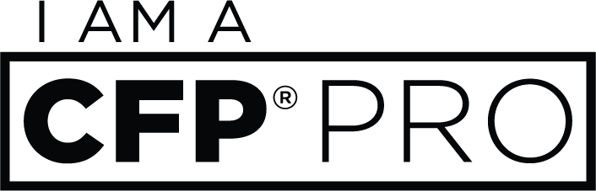

Social Media Toolkit for
CFP® Professionals

As part of the “I am a CFP® Pro” campaign to attract more young people into the financial planning profession, the following are suggested social posts that CFP® professionals are encouraged to share on their social channels.
Helpful Links:

“I am a CFP® Pro” campaign website: www.CFPpro.org
Includes testimonial videos from real CFP® pros on why they love their career
Resources for CFP® professionals: https://www.cfp.net/for-cfp-professionals
Toolkit for CFP® professionals that includes the CFP® marks as well as a Social Media Guide for reference.

General Tweets:
- Thinking about switching careers? Check out www.CFPPro.org to see why financial planning could be the perfect fit! #CFPPro
- I am among the xx,xxx people who have earned their CFP® certification. Find out how you could join the growing ranks of CERTIFIED FINANCIAL PLANNER™ professionals #CFPPro www.cfppro.org [Note: Click here for the latest CFP Board statistics, including number of CFP® professionals.]
- I love being a CERTIFIED FINANCIAL PLANNER™ professional! Hear from other pros on why financial planning is a great career choice! #CFPPro www.cfppro.org
- As someone who has a career in financial planning, I know that it’s about more than just money. Being a CFP® professional offers flexibility & the opportunity to help others #CFPPro www.cfppro.org
- To anyone considering a career in financial planning: On average CFP® professionals make 26% more money annually, based on experience, in comparison to other financial advisors #CFPPro www.cfppro.org
- I pursued my CFP® certification so I could stand out as one of the best in the financial planning field. To find out more about financial planning or becoming a CFP® professional, visit www.cfppro.org #CFPPro
- Becoming a CERTIFIED FINANCIAL PLANNER™ professional added great value to my life. With the possibility to earn 10 – 30% greater annual raises by switching careers, a career in financial planning could be extremely beneficial #CFPPro www.cfppro.org
- Take it from a CFP® professional – check out www.cfppro.org to learn about careers in financial planning and see how to get started! #CFPPro
- Do you or anyone you know have an interest in finance and enjoy helping others? Check out the “I am a CFP® Pro” campaign and spread the word! #CFPPro www.cfppro.org
- The financial planning field is looking for new financial planners. With close to 20% of CFP® professionals nearing retirement, now is the perfect time to learn more about this in-demand career field #CFPPro www.cfppro.org
- As a CFP® professional, I’ve been able to make a positive impact in other’s lives. Learn how the CFP® certification provides the training and expertise to help make a difference #CFPPro www.cfppro.org
- Being a CERTIFIED FINANCIAL PLANNER™ professional has been nothing but rewarding! If anyone is interested in learning more about the profession, visit www.cfppro.org to get info straight from the pros #CFPPro

Facebook/ LinkedIn Posts:

- For anyone contemplating a career change, I highly recommend considering the financial planning field. Check out CFP Board's “I am a CFP® Pro” campaign to hear financial planning pros share their personal experiences about earning the CFP® certification, as well as what it means to be a CERTIFIED FINANCIAL PLANNER™ professional. #CFPPro www.cfppro.org
- Interested in an exciting and rewarding career? Consider becoming a financial planner. As a CFP® professional, I help numerous individuals and families take control of their money and reach more than just their financial goals. Financial planning is an in-demand career that fosters personal development and fulfillment. #CFPPro www.cfppro.org
- Feeling stuck in your career and interested in finance? Becoming a CERTIFIED FINANCIAL PLANNER™ professional allows for flexibility and potential to reward both yourself and others. 70% of CFP® professionals, including myself, believe that the CFP® certification promotes greater confidence and trust from clients, as well as the ability to provide a deeper level of knowledge. Learn more at www.cfppro.org. #CFPPro

Instagram Posts:
Share a photo of yourself with a story or statement on why you love your career as a CFP® pro. Feel free to use and/or modify any of the text above, as well. Be sure to link to www.CFPPro.org and use the #CFPPro hashtag.

